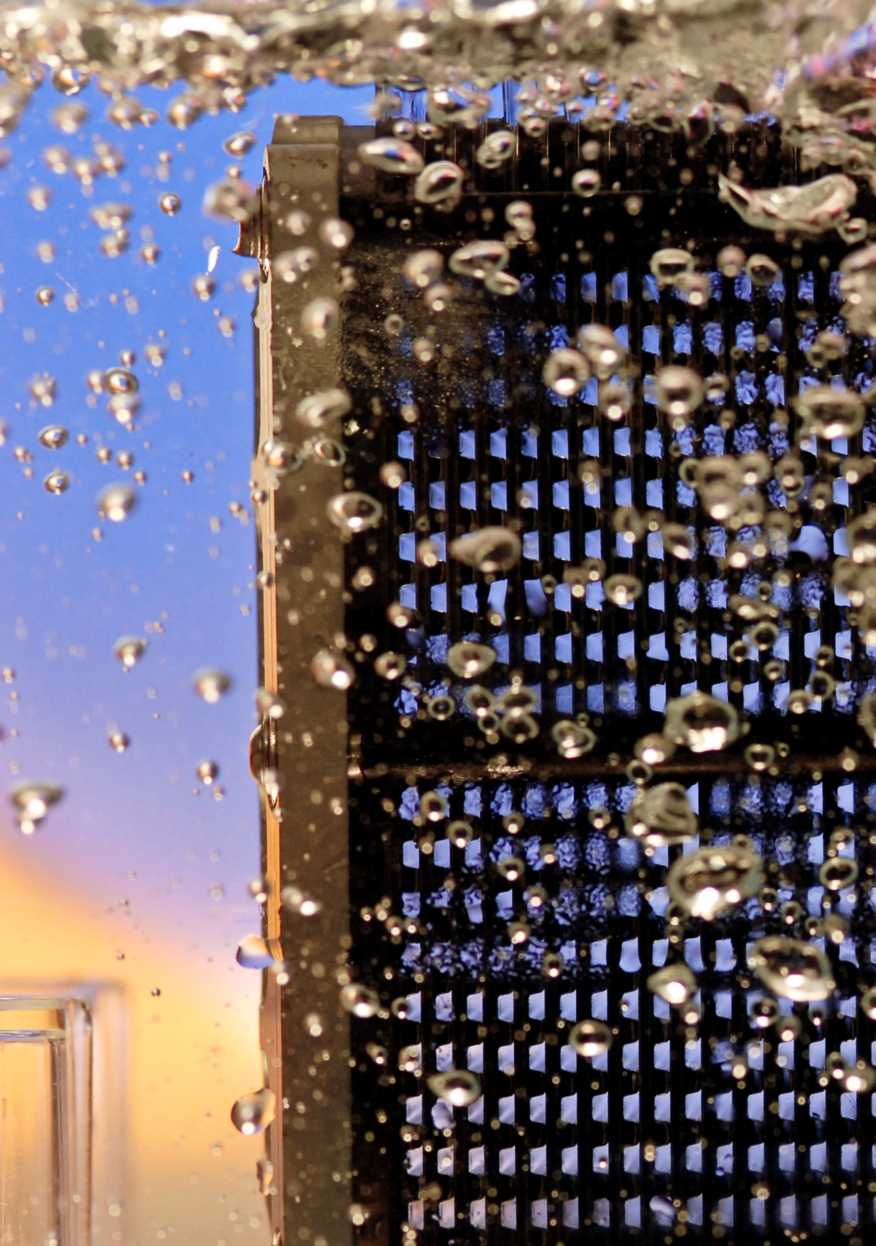

|  |
| --- |
| FUEL CELL INDUSTRY ANALYSIS REPORT |
| 2015 |

Bambu, the Team

|  |  |
| --- | --- |
|  | ****Benoit Serot****  ****Product Description****  Currently in his first year of Master of Science in the Industrial Engineering Department of Tsinghua University, Benoit Serot has been studying electrical and information engineering for two years before coming to China. What with such a background, he strongly believes in the potential of alternative sources of energy to fossil fuels. |
|  |  |
|  | **Pongsathorn Tiranun**  **Market Perspective**  Hailing from Thailand, Pongsathorn Tiranun is an enthusiastic candidate of the 2 years MSE program of Industrial Engineering Department, Tsinghua University starting from the year 2014. He already took a keen interest in ‘Fuel Cell’ since the time he was doing his Electrical Engineering Degree earlier, he takes this IAR as a good opportunity to research more on fuel cells. |
|  |  |
|  | **Konstantin Neumann**  **Introduction, Policy Framework**  At the moment Konstantin Neumann is taking part in a two semester exchange program at Tsinghua University. After finishing his B. Eng. he started his M. Sc. in Industrial Engineering at TU Darmstadt in Germany. |
|  |  |
| **Acknowledgement**  This Report is the result of a project during the class Global Manufacturing Strategy at Tsinghua University, Beijing China in spring term 2015. Therefore we want to thank Professor Benjamin Koo for his guidance in this project. Furthermore we want to thank all collaborators who gave advices either directly in the classroom or through the collaboration tool GitHub. | |

Table of contents

1. Introduction 4

1.1 Intentions 4

1.2 History of Fuel Cells 6

1.3 Fuel Cell as an alternative? 7

1.4 Quick industry overview 7

2. Product Description 8

2.1 Introduction 8

2.2 Technologies 9

2.3 Applications 14

2.4 Infrastructure 18

3. Market Perspective 22

3.1 Introduction 22

3.2 Investment Cost Reduction 23

3.3 Intellectual Property 23

3.4 Quantity of Fuel Cells Shipped 25

3.5 Company Profiles 28

4. Policy Framework 37

4.1 Situation in Japan 39

4.2 Situation in the USA 40

4.3 Situation in Germany 40

4.4 Conclusion 41

5. Future perspectives 42

5.1 Fuel Cells as Off-Grid Power Source 42

5.2 Hydrogen Infrastructure 43

5.3 Technology 44

6. Conclusion 45

7. Appendix 47

7.1 Detailed table of contents 47

7.2 List of figures 49

7.3 List of tables 50

7.4 Contribution on GitHub 50

7.5 References 51

# Introduction

One of the tools used during this project is a logic model which is shown in Figure 1. It shows the general purpose of the report and gives a rough outline of what is included in this report. Also the used resources and activities are shown.

Visit the webpage to read, download or participate via GitHub



## Intentions

As shown in the logic model the report aims at informing about the state of the fuel cell industry. The report is targeting readers who want to learn more about the technology, but especially it is targeting global policy institutions. This is a large group of people, and can include those who are in contact with fuel cells for the first time as well as those who already have a profound expertise in this field. Therefore the report gives a short introduction of history and also explains the different types and working mechanisms of fuel cells but also shows threads and chances by linking the gathered knowledge with new topics like block chain.

**http://bambugms.github.io/Industry-Analysis-Report/**

The underlying information for this report was gathered by a broad literature and internet research. Knowledge from previous Industry Reports as well as research papers, newspapers, press releases and governmental authorities were used to collect and show a broad spectrum of facts.

Figure : Logic Model

Rationales

IAR beneficial for consumer, global policy institutions

Resource

* Fuel cell authorities
  + Fuelcelltoday
  + Fuelcell.org
* Scientific publications
  + e.g. Sciencedirect
* Company websites
* Newspapers and magazines
* Governmental authorities
  + Energy.gov
* Statistic databases
* Online Tools
  + GitHub
  + Teambition
* Software
  + MS Office
  + Atom
  + Citavi

Activities

* Create the IAR
  + describe historical evolution
  + Identify the leading technologies and potential applications
  + determine shipment data, investigate about companies
  + Review governmental regulations and subsidies
  + Analyze potential development and threads of other technologies
* Publish IAR online and link it to printed version

Outputs

* IAR
  + Brief historical outline
  + Explanation of technologies and applications
  + Show price development, shipped units, company profiles and their IP
  + Show how policies are varying in different countries
  + Show risks and opportunities in the context of other technologies
* Github page

Outcomes

* Condensed Information about the fuel cell industry available
  + IAR available to everyone
  + IAR understandable by everyone
* Interaction with other contributors

Problem

Goal

Fuel cells are an alternative to fossil fuels, yet there is a lack of knowledge about fuel cells and the state of the industry.

l cells are an alternative to fossil fuels, yet there is a lack of knowledge about fuel cells and the state of the industry.

Provide an open Industry Analysis Report (IAR) in order for global knowledge and development opportunities to become available to anyone especially global policy makers.

## History of Fuel Cells

The beginnings of fuel cells reach back to 1838. At this time William Robert Grove worked on what was later called a fuel cell. Grove, who is credited with the invention of the fuel cell, used platinum together with hydrogen and oxygen to create a constant current. Several scientists including Christian Schönbein tried to show how exactly fuel cells are working. Although great discussions and large efforts, it took several years to explain the complete system. In the early years no practical device emerged. In the early 20th century the first molten carbonate fuel cell was built by Emil Baur. Further investigations were made by Francis Thomas Bacon who developed first fuel cells with a practical use. His work was promising enough to be licensed by Pratt & Whitney for the Apollo missions. From the 1960s the history is becoming more branched as the different technologies, developed independently[1].

At General Electric Willard Thomas Grubb and Leonard Niedrach invented the first PEMFC which was later refined and used by NASA for the Gemini Mission in the 1960s. International fuel cells developed other systems for the Apollo missions. Also in the Soviet Union there was research in this field of technology, mainly for military purposes, later also for space missions. Driven by the oil crisis in the 1970s nearly all major car manufacturer had developed a FCEV. Another effect of the oil shortage was progress in the development of PAFC which are allowing to reach higher power outputs. Although high growth rates were predicted in the 1980s, there was just a slow adaption of the new technology. In the 1990s the focus was laid on small stationary applications[2]. Also the first battery of methanol was developed as a portable device. Another promising field is the public transport, especially buses, where first models where available around 2000. First applications for end users included auxiliary power units, e.g. for caravans. In the 2007 the first hydrogen car was presented, the Honda FCX Clarity, which was available for customers since 2008 for leasing. Since then many other models from different manufacturers are available. Residential fuel cells as well as micro devices, like phone chargers became more popular and available during the last years. Therefore the industry is changing from mainly R&D focused to commercializing of products[3] [4]. The strongest development on the market is happening since the 1990s. The market now includes large companies from energy equipment, chemicals and materials sectors and new start-up firms[5].

**PEMFC**: Proton Exchange Membrane Fuel Cell

**FCEV**: Fuel Cell Electric Vehicle

**PAFC**: Phosphoric Acid Fuel Cells

## Fuel Cell as an Alternative?

Fuel cells can be used as a substitute as well as a complementing technology. The applications can be divided into the three categories stationary, transport and portable (cf. 2.3 Applications). The area of stationary fuel cells includes systems like plants or one household systems. In this area it is possible to complement for example regenerative energies with fuel cells to store the energy during the time it is not needed and by doing so building a smart network. As it is a clean and very fast reacting technology it can be also used in cities, for example instead of gas plants. Portable systems in different scales can be used for example as a supplement for diesel generator to support of grid systems with energy. Micro systems compete with traditional batteries. The transport sector is probably the most competitive area as fuel cells are in direct competition with traditional fuel as well as electrical energy powered cars. Further discussion about the possible future discussion will be hold in Part 5.

## Quick Industry Overview

As pointed out in the history section above the fuel cell market for customers is quite young and therefore still shaping itself rapidly. On the market there are several big players as well as niche producers. In general big stationary systems (e.g. plants) are built by bigger companies whereas the portable systems are mostly distributed by smaller companies. The fuel cell market is strongly varying according to regional factors, which was the reason to divide the analysis of the market in part 3 in three main regions.

# Product Description

**Chemical representations:**

* Oxygen (O)
* Hydrogen (H)
* Water (H2O)

**Electrode:** An electrical conductor used to make contact with a non-metallic part of a circuit. (Wikipedia contributors 2015a)

**Electrolyte:** A substance that ionizes when dissolved in suitable solvents such as water. (Wikipedia contributors 2015b)

**Reduction:** Chemical reaction during which an element gains electrons.

In this second part, the reader will be provided with an explanation on the way a fuel cell works. A listing of the different technologies available today will also be made according to their characteristics. These define the application perspectives for the product. In the end, one paragraph will be dedicated to the infrastructure necessary to the production and the distribution of hydrogen.

The aim of the section is to give the reader the keys to understand the results of the market analysis that will be led farther in this report with a product view.

## Introduction

The basic principle underlying in the fuel cell technology is to combine oxygen and hydrogen to produce electricity and water. As well as a battery, it provides electricity out of a chemical reaction. The main difference lies in the fact that a fuel cell uses an external sources of hydrogen and oxygen to keep running. The hydrogen source will later be referred to as the fuel.

The structure of the product is meant to enable such a chemical reaction. It consists of an electrolyte and 2 electrodes. The electrolyte is the element that sets the temperature of operation. The range of temperature then determines what catalyst is to be used in order to accelerate the reaction and what fuel can be used. What with the electrodes, they are of two types: the anode where the fuel is being oxidized, and the cathode where oxygen gets reduced. As a result, the voltage of a fuel cell circuit has an order of magnitude of 1 V. Higher values can be reached by assembling several fuel cells in stacks.

***A fuel cell combines oxygen and hydrogen to produce electricity and water.***

**Oxidation:** Chemical reaction during which an elements gives electrons away.

**Fuel Cell Abbreviations:**

* PEMFC: Proton Exchange Membrane Fuel Cell.
* AFC: Alkaline Fuel Cell.
* PAFC: Phosphoric Acid Fuel Cell.
* SOFC: Solid Oxide Fuel Cell.
* MCFC: Molten Carbonate Fuel Cell.
* DMFC: Direct Methanol Fuel Cell.
* LT: Low Temperature
* HT: High Temperature

**Polymer:** A polymer is a kind of chemical molecule. It is a large molecule in which subgroups of elements are repeated sequentially. The basic subgroup defines the type of polymer.

## Technologies

Research has led today to the development of different fuel cell types. They vary in terms of electrolyte, catalyst, but also in their operating temperature window. Another characteristic that defines them is their tolerance to impurities in the fuel. Indeed, even though hydrogen represents the most abundant chemical element in the universe, it is the most volatile as well. As a consequence, it combines with other elements to form more complex molecules that cannot directly be used as fuels. Eventually, each fuel cell type has its proper power output range, power density, and efficiency, which are determinant in their application perspectives.

In this paragraph, we will give these details about the six most common fuel cell types: PEMFC, AFC, PAFC, SOFC, MCFC, and DMFC[6] [7]. They all have already been developed in a commercial context, which testifies of the reliability of their characteristic.

### PEMFC

Figure 2: Schematic representation of the structure of a PEMFC



HYGROGEN

EXCESS HYGROGEN

OXYGEN

WATER

HYDROGEN IONS

ELECTRONS

**ELECTROLYTE**

**CATHODE**

**ANODE**

The proton exchange membrane fuel cell is made of polymer electrolyte. According to the basic component of it, it can operate at low or high temperatures.

Low temperature PEMFC have a water-based electrolyte. They can operate from 40 to 90 °C. This gives them the advantage of handling cold start. However, this temperature range combined with the fact that their electrodes are platinum-based (a noble metal) gives them only little tolerance to impurities in the fuel. Consequently, they have to be run with pure hydrogen. They are appropriate to deliver dynamic supply which gives them all the characteristics for transport uses.

**Alkali:**  A basic, ionic salt of an alkali metal or alkaline earth metal chemical element. (Wikipedia 2015a)

**Alkaline elements:** Elements part of the second of the periodic table of elements.

The typical output range for LT PEMFC is between 1 mW and 100 kW and the power density around 0.7 W.cm-².

PEMFC can also operate at high temperatures. In such a case, the electrolyte is replaced by a mineral acid-based polymer and the acceptance of impurities in the fuel is improved.

### DMFC

The direct methanol fuel cell is made of the same kind of membrane polymer electrolyte as the PEMFC (for the schematic representation cf. 2.2.1 PEMFC). It therefore works at similar temperature. The main difference between the two comes from the catalyst which permits the transformation of methanol into carbon dioxide and hydrogen ions at the anode of the device. Methanol is a cheap fuel and easy to store and transport compared to hydrogen. However, the reaction involved rejects carbon dioxide.

DMFC are usually used for low power applications such as in mobile devices. Its output can indeed only reach 1 kW. The power density of DMFC can go up to 0.25 W.cm-².

### AFC

Figure 3: Schematic representation of the structure of an AFC



HYGROGEN

WATER

OXYGEN

EXCESS OXYGEN

HYDROXYDE IONS

ELECTRONS

**ELECTROLYTE**

**CATHODE**

**ANODE**

Alkaline fuel cell is a name that comes from the fact that the electrolyte consists of an alkaline. The most common one is potassium hydroxide. Thanks to it, the temperature window is large, from 40 to 200°C. In addition to this, the electrodes of the AFC do not have to be made of noble-metals. However, its spread is limited because of the complete intolerance to impurities in hydrogen.

**Combined Heat & Power System (CPH):** System that uses a heat engine or power station to generate electricity and useful heat at the same time. (Wikipedia 2015b)

The power output can be expected to be between 1 and 5 kW and the power density between 0.1 and 0.3 W.cm-².

### PAFC

Figure 4: Schematic representation of the structure of a PAFC



HYGROGEN

EXCESS HYGROGEN

OXYGEN

WATER

HYDROGEN IONS

ELECTRONS

**ELECTROLYTE**

**CATHODE**

**ANODE**

The Phosphoric Acid Fuel, as opposed to alkaline ones, can accept carbon monoxide in their fuel up to 2 %. Their electrolyte is made of phosphoric acid and the electrodes with platinum. The resulting operating temperature is around 200 °C. This type of fuel cell has a low efficiency in itself (55 %), but can be integrated into combined heat and power structures in order to reach an 80 % system ratio.

Its typical output range is higher than the previously mentioned fuel cells with an upper limit of circa 200 kW, which encourages its integration into industrial or commercial heat and power systems. The power density of such cell lies around 0.14 W.cm-².

### SOFC

**Yttrium-stabilized zirconia:** YSZ is a-ceramic combining oxides to stabilize its structure.

Figure 5: Schematic representation of the structure of a SOFC



HYGROGEN & CARBON MONOXDE

CARBON DIOXIDE & WATER

OXYGEN

EXCESS OXYGEN

OXYGEN IONS

ELECTRONS

**ELECTROLYTE**

**CATHODE**

**ANODE**

Another HT operating fuel cell is the solid oxide fuel cell. It can be run between 600 and 950 °C. This is due to the solid ceramic electrolyte of the cell (mostly yttrium stabilized zirconia). It provides a great resistance to impurities, as natural gas or even hydrocarbons can be used as fuels. In addition to this, the heat facilitates chemical reactions, and no catalyst is hence needed. The efficiency of SOFC is higher than the one of PAFC, but it remains interesting to use them as combined heat and power units. This is one of their main applications for domestic use. However, their power output range being very wide, from 1 mW to 5 MW, they can also found an application as small electronic charger. Their power density is between 0.15 and 0.7 W.cm-².

### MCFC



HYGROGEN & CARBON MONOXDE

CARBON DIOXIDE & WATER

OXYGEN

EXCESS CARBON DIOXIDE & OXYGEN

CARBONATE IONS

ELECTRONS

**ELECTROLYTE**

**CATHODE**

**ANODE**

CARBON DIOXIDE

Figure 6: Schematic representation of the structure of an MCFC

Eventually, the molten carbonate fuel cell can also deliver a high power output (up to 5MW). It consequently is typically used in large heat and power plants. Its temperature window indeed is around 650 °C, which again improves its tolerance in terms of fuel. Its electrolyte consists of a molten carbonate salt, made of components such as lithium, sodium and carbonate potassium. Carbon dioxide has to be injected on the side of the cathode in order to form the carbonate ions that will circulate in it. Once again, its high operating temperature only allows a slow start. It has a low power density, between 0.1 and 0.12 W.cm-².

In order to understand what fuel cell technology is through an explanative video and to have an introduction about the following parts, you can visit the U.S. Department of Energy’s YouTube account and watch:

**Energy 101: Fuel Cell Technology**

[**https://www.youtube.com/watch?v=QFQGXei47c0**](https://www.youtube.com/watch?v=QFQGXei47c0)

### Conclusion

Among the six types of fuel cells presented above, various output power ranges and operating conditions are available. According to the fuel that is to be used, the output expected (power only or combined power and heat), the profile of the energy demand (stable or not) and the size of the cell, these products already provide a wide range of options, which makes various applications conceivable.

The following table is storing the characteristics mentioned previously in a normalized way.

Table 1: Summary of the different fuel cells and their operating conditions

|  |  |  |  |  |  |  |
| --- | --- | --- | --- | --- | --- | --- |
| **Type of FC** | **Electrolyte** | **Fuel** | **Operating Temp. (°C)** | **Output Range** | **Cell Efficiency (%)** | **Power Density (W.cm-²)** |
| LT PEMFC | Polymer (Water Base) | H2 | [40, 90] | 1 mW – 100 kW | [50, 70] | 0.7 |
| HT PEMFC | Polymer (Mineral Acid Base) | H2 (/CO) | [125, 220] | 100 W – 10 kW | [50, 70] | 0.7 |
| DMFC | Polymer | Methanol | [60, 130] | 1 mW – 1 kW | [20, 30] | 0.25 |
| AFC | KOH | H2 | [40, 200] | 1 kW – 5 kW | [60, 70] | [0.1, 0.3] |
| PAFC | Phosphoric Acid | H2 (/CO) | 200 | 25 kW – 200 kW | 55 | 0.14 |
| SOFC | Solid Oxide | CH4, H2, CO | [600, 950] | 1 mW – 5 MW | [60, 65] | [0.15, 0.7] |
| MCFC | Molten Carbonate | CH4, H2, CO | 650 | 50 kW – 5 MW | 55 | [0.1, 0.12] |

Non-noble metal

Noble metal

Noble or non-noble metal

Electrodes:

## Applications

The second paragraph of this part is setting the emphasis on the characteristics of six specific fuel cell products. In doing so, it followed the conventions already used by other informative organs such as FuelCellToday which defines itself as *the leading authority on fuel cells*. This paragraph being dedicated to the different applications of fuel cells, it will remain consistent with these norms in order to help them become references for the whole fuel cell industry. They differentiate three different range of applications according to the use that is made of the fuel cell corresponding to the following contexts[8] [9]:

* **Transport**: Units providing propulsive power to a vehicle.
* **Stationary**: Units providing power (and sometimes heat) but are not meant to be mobile.
* **Portable**: Units integrating systems designed to be moved.

Boeing’s project to build a completely hydrogen powered unmanned aircraft is advertised on YouTube:

**Boeing's fuel cell technology is making sustainable flight closer to reality**

[**https://www.youtube.com/watch?v=SrTkT7OpcpI**](https://www.youtube.com/watch?v=SrTkT7OpcpI)

### Transport

“Units providing propulsive power to a vehicle.”

This definition matches with the most advertised fuel cell application: hydrogen cars. However, fuel cell power can also be used for other vehicles. As an example, boats or even submarines can work with hydrogen. In addition to reduce polluting gas emission, it presents the advantage of being silent.

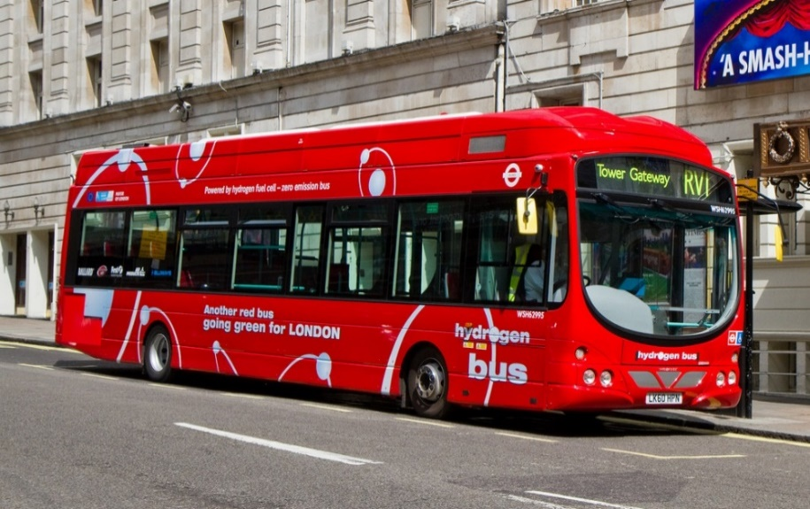

Figure 7: A hydrogen powered bus in London

Some light aircrafts are also fuel cell powered, with companies such as Boeing showing their interest for the technology. Other applications in the professional world are light-duty vehicles, forklifts or trucks.

### Stationary

“Units providing power (and sometimes heat) but are not meant to be mobile.”

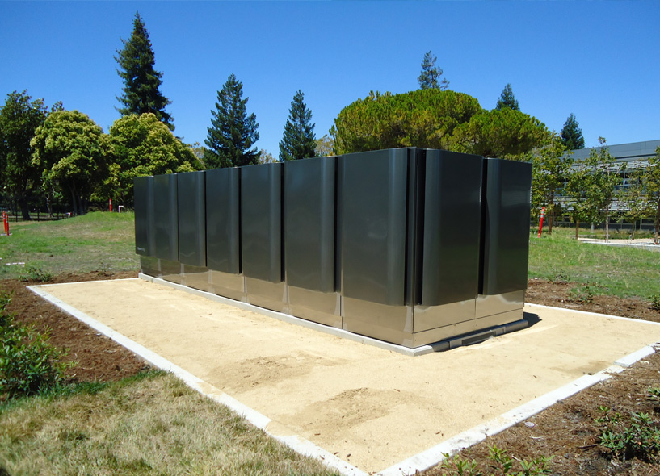These applications represent a particularly high ratio in the hydrogen power. The main reason is that they include large power plants. Those can be built in remote places where electricity is hard to “ship” in order to improve the reliability for users by implementing off-line supplies. As an examples, they might be useful for some factories or villages that are hardly reachable. The fact that a fuel cell can work off-line makes it have an advantage towards Uninterruptible Power Systems (UPS).

Figure 8: SOFC installation by Bloom Energy at a NASA centre

**UPS** Uninterruptible Power System

In UPS, fuel cells are often installed as backup supply units that would be able to keep running and provide electricity even in case of a failure from the grid. As an example, it can be used for servers or other IT products.

A stationary application can also be of smaller scale, for simple residential use. It corresponds to the context in which a power and heat combination can be fully exploited and is all the more advantageous for the user. Those units are spreading in Asian countries such as Japan and South Korea thanks to government incentives.

### Portable

If you are curious about how to charge your phone with hydrogen, you can visit this YouTube page:

**Fuel-cell phone charger makes its own electricity**

[**https://www.youtube.com/watch?v=EvrUjMa-AEo**](https://www.youtube.com/watch?v=EvrUjMa-AEo)

“Units integrating systems designed to be moved.”

Figure 9: A fuel cell charger designed by Brunton, using small hydrogen reservoirs to refuel.

Portable units are designed to charge or be part of portable devices. Auxiliary power units (APU) that can be used to charge electronic devices are therefore mart of them. They can also integrate portable systems such as a torch, a music player, or even a personal computer. Thereupon they represent a field of investigation for military laboratories. Indeed, a fuel cell powered device discharges more slowly and recharges more quickly than one running a conventional battery, which increases reliability. In addition to this, it operates silently weights little, and can work off-grid.

### Conclusion

Table 2: Summary of the different applications for fuel cells

|  |  |  |  |
| --- | --- | --- | --- |
| Category | Power Range | FC Type | Applications |
| Transport | 1 kW to 100 kW | * PEMFC * AFC | * Personal Vehicles (cars; motorcycles; scooters) * Transportation (planes; trains; boats or ferries) * Military use (plane; submarine) * Support to other power supplies |
| Stationary | 0.5 kW to 5 MW | * PEMFC * SOFC * MCFC * PAFC * AFC | * Residential supply (CHP or simply power) * UPS * Primary power units (large or small prime power plants) |
| Portable | 5 W to 500 kW | * PEMFC * DMFC | * APU * Personal electric devices (small or large) * Military use |

## Infrastructure

Figure 10 : The Air constitution

The air present on the surface of Earth is made of 78,08 % of dinitrogen, 20,95 % of dioxygen, and 1 % of other gas. Hydrogen represents only a 0,000072 % fraction of it.

As explained previously, a fuel cell is a product able to produce energy out of a chemical reaction that minimizes polluting emissions compared to traditional gas power engines. This reaction nevertheless is not completely natural in the way that it has to be triggered by some specific conditions such as the temperature, the electrolysis structure, and eventually, the supply in a fuel: hydrogen. Depending on the model, hydrogen can be of more or less pure constitution, but the air we breathe does not have a high enough concentration in it to consist of a fuel. As a consequence, the gas used needs to be processed and stored before it is distributed to the operating units.

These steps are preceding the fuel cell exploitation. As a consequence, the fuel cell and the hydrogen industries are profoundly correlated by justifying each other. Indeed they could not survive separately. This paragraph provides a short introduction to the hydrogen distribution infrastructure, which is essential to be thought of for fuel cells to be adopted by the general public. In a second part, it will address two different hydrogen production modes and their implementation conditions.

### Distribution Facilities

Hydrogen is the lightest chemical element on earth. In such a normal environment, it has the state of a gas. It therefore is volatile and its volumetric mass is very low. As a consequence, in one given unit of volume, there is less hydrogen than there would be of any other element (8 MJ.L-1 against 32 MJ.L-1 for gasoline). And less hydrogen implies less fuel. Hydrogen therefore 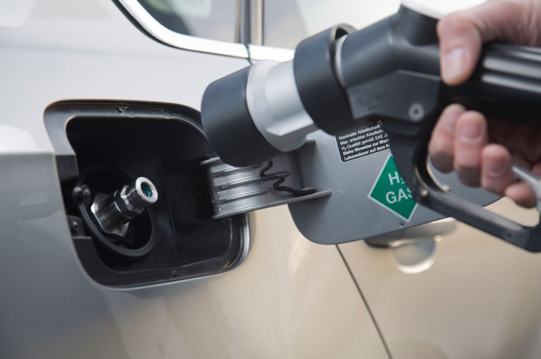is a costly fuel to ship.

Figure : A hydrogen "plug" on a car

Delivery

**Hydrogen Transportation:**

* Pipeline
* Conventional transportation modes

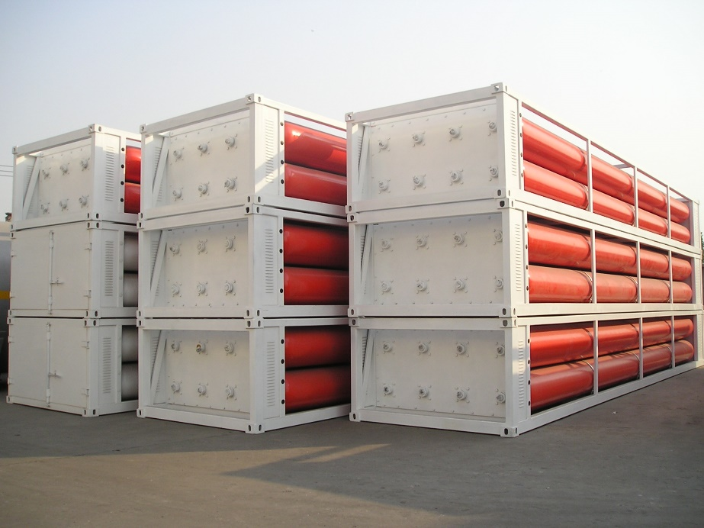Today, there are three different ways of transporting hydrogen, in pipelines, or in containers. The first option is particularly expensive in the short term because it requires a complete network and infrastructure to be built in order to adapt to users’ needs. It is the best way to transport large quantities of fuel. The second option is adapted to smaller needs, by storing hydrogen into closed containers that can then be shipped by conventional methods (truck, train or boat carriage). Again, there exist two possibilities to do this. The first one is to compress hydrogen and store it into high pressure tubes. The other one is to liquefy the fuel in order to put it into liquid insulated tankers. However, this option remains costly because it requires to bring the gas at its liquefaction temperature, -253 °C and then to use adapted refrigerating devices. The advantage of it is that is holds more fuel per volume unit.

Figure 12: Hydrogen high pressure tubes designed by Shijiazhuang Enric Gas Equipment Co.

Eventually, as it is the properties of hydrogen that make it hard to transport, it is also possible to mix it with other elements in order to ship it as ethanol or ammoniac for example. However, the drawback of this method is that a dehydration process has to be carried before use. This last method is referred to as carrier and is still at a development stage.

#### Hydrogen Storage

With regards to the previously addressed problems related to hydrogen delivery, storage is also a delicate task, especially when it comes to achieve this in a moving vehicle. Several solutions have been implemented:

Figure 13 : Illustration of the different storage modes for Hydrogen

### Hydrogen Production

Fuel cell is a promising zero-emission concept. Nevertheless, because it is in addition to delivery and storage a costly process in terms of energy. Whether hydrogen power is green or not then depends on how it is produced. Today, the sources are natural gas, electricity, solar energy and biomass. The second one is all the more interesting with the fact that it can be collected from natural energy such as wind, solar, or biomass power. Solar and biomass energy however can be involved in direct hydrogen production, which differentiates them from conventional electric sources.

In this paragraph, the emphasis will lie on two specific hydrogen production modes, gas reforming and electrolysis. The first one is already well adopted in the hydrogen industry. As an example, it is responsible for 95% of the hydrogen production in the United States[10]. The second works thanks to electricity. It therefore is adaptable to various sources of power and can easily integrate existing electrical grids.

#### Gas Reforming

It is today the main hydrogen production mode because the process is mature and can respond to large needs of the users. It relies on chemical reactions involving methane (CH4):

* Partial Oxidation
* Steam Reforming

Gas reforming is criticized because of its greenhouse gas emissions. It nevertheless remains lower than what results of the use of gasoline power engines.

#### Electrolysis

The idea behind the electrolysis is to reverse the fuel cell process, i.e.: use electricity to split water into oxygen and hydrogen.

The technology required therefore is similar to the one of fuel cells, proton exchange membrane, alkaline and solid oxide electrolysers being preferred in practice.

Electrolysis units can easily integrate power systems. They can be of various size just as well as fuel cell and hence can be used in residential or industrial contexts. This is particularly interesting because it raises the question of centralized or distributed production. Indeed, the previous paragraph about Distribution Facilities mentioned some of the difficulties storage and delivery have to overpass. Decentralizing the production of hydrogen could help reduce delivery-related problems. What with storage, its resort could be minimized with dynamic production units, available thanks to the PEM technology (cf. 2.2.1. PEMFC).

# Market Perspective

**CHP:**

Combined Heat and Power. The process of generating useful heat and electricity at the same time. Scan the QR below to learn more about CHP.



<http://en.wikipedia.org/wiki/Cogeneration>

**FCEV:**

Fuel Cell Electric Vehicle.

A vehicle in which fuel cell is used to power its electric motor.

## Introduction

In general, the trends for the fuel cell industry have been positively increasing for a few years, manufacturing costs continued to decline especially for the transportation applications while at the same time hydrogen infrastructures are continually being deployed in many countries to support the new FCEVs which be launched into to market in the near future.

Like its applications, the markets for fuel cells can be broadly divided into 3 subcategories as previously mentioned in chapter 2:

1. **Stationary power:** applications where the fuel cells are working at a stationary or fixed location mostly for primary power, CHP or backup power sources;
2. **Transportation power:** applications where fuel cells are used in transportation vehicles like passenger cars, buses and other FCEVs ;
3. **Portable power:** applications where fuel cells are in portable electronic devices like MP3 players, laptops, and mobile phones.

## Intellectual Property

The data in this section is referring to the Clean Energy Patent Growth Index report which keeps tracks of clean energy patents and covers many sectors involved, including fuel cells.[11]

In brief, automakers took most control. Toyota Corporation has once again been receiving most fuel cell patents since it did so in 2012, now with 101 in total. While General Motors Corporation with 89 patents comes as the second highest. Samsung and Honda are in the third and fourth places respectively. The approximate number of patent entities granted is 300. The figures below show the distribution between the top ten assignees and how the patents are distributed geographically.

**Did You Know?**

Most of the patents awarded to the top three assignees in the recent years cover the innovations of fuel cells existing in the automotive industry. Also the R&D department of General Motors Corps invested less in FC technology as a result form the American Recovery and Reinvestment Act.

Figure 15 : Top 10 Fuel Cell Energy Patent Assignees 2002 - 2014

**What makes Japan the biggest market in terms of megawatt shipped?**

Most stationary cells are shipped to Japanese market where the government encourages the usage of CHP, Japan is also the biggest customer of stationary fuel cells. Read more about the policy in Japan in Part 4.

Figure 16 : Fuel Cell Patents Geographic Distribution

## Quantity of Fuel Cells Shipped

A way to categorize the fuel cell shipments is to divide them according to their corresponding applications: stationary power, transportation power and portable power. Transportation power used to be the majority of the shipped system in 2008. However, with the introduction of the CHP units in the market, residential units of CHP were continuously deployed in Japan. And in the year 2013 alone, more than 26,000 units have been shipped to Japan. The shipments of transportation and portable FC have been quite stable and experts forecast that it will remain so at least for a couple of years.

Figure 17 : Fuel Cell MWs shipped by Applications (2008-2013)

From the figure above, we may notice that portable shipments are not visible. This is mainly because the power consumed by portable type fuel cell is normally negligible when compared to that of the other two categories. Majority of stationary FC displayed in this graph is contributed from CHP units, telecommunication backup power generation, off-grid power supplier for CCTVs and energy sources for other stationary military devices.

**Why are portable applications invisible in the Graph?**

For fuel cell products belonging to the portable category, the power usage by the application is dramatically lower than the other two categories. Hence, the portable application power is seemingly invisible in the graph.

Figure 18 : Fuel Cell System Shipped by Application (2008-2013)

Figure 19 : Fuel Cell Systems Shipped by Major Manufacturer Countries (2008-2013)

Figure 20 : Fuel Cell Systems Shipped by Major Manufacturer Countries (2008-2013)

In terms of countries, the US FC shipments remain quite stationary and the growth is stagnant mainly due to the end of federal American Recovery and Reinvestment Act or (ARRA) which leads to the decline in fuel cell shipments but the decline is expected to be reversed in the few years. When the policy will be re-enacted, it will encourage a number of companies to deploy fuel cells at their warehouses.[12] For fuel cell electric vehicles, the global shipments remain quite low. This is because the major auto manufacturers planned to release their commercial fuel cell electric vehicles starting in the year 2017. The significant company that took initiative in shipping commercial fuel cell vehicles is Hyundai who started the shipment to European Region in the year 2013.[13]

## Company Profiles

Currently the fuel cell market has flourished with many companies developing a variety of different products ranging from small hand held fuel cell mp3 players to big fuel cell substations used as backup power for vital communications. In order to enable the reader to understand the estate of the fuel cell market more concretely, an introduction of fuel cell companies from all corners of the world is given in this part. Notice that this is not an exhaustive list of the manufacturers, since there are many public and private companies in existence. However, the company profiles mentioned in this chapter should prove significant to give insight to the entire fuel cell industry.

Here is the list of companies included in this IAR in alphabetical order:

* Bloom Energy
* Horizon Fuel Cell Technologies
* Intelligent Energy
* Nedstack
* Panasonic
* Plug Power
* SFC Energy
* Toshiba



### Bloomenergy

**Bloom Energy Website:**



[**http://www.bloomenergy.com/**](http://www.bloomenergy.com/)

Bloom Box (picture on the lower side of this page), a bloom energy product is designed to operate under extreme conditions of temperature, it can withstand up to 1800 Fahrenheit

The company was founded in the year 2001 and is headquartered in Sunnyvale, California. Its first customer was the University of Tennessee, which ordered the company a SOFC product for educational purposes in 2006. Many other universities across the United States similarly ordered the same product to conduct field trials. But it wasn’t until July 2008 that the first commercial version of Bloom Energy’s products were shipped to Google. The company proved to be one of the most well-known SOFC producers since its establishment some notable customers of this firm includes: Adobe, Bank of America, Coca-Cola, eBay, Google, Kaiser Permanente, and Walmart. The Company claimed that their products have already generated more than 100 million kilowatt-hours of clean energy for its customers.[14]

Table 3 : Brief market information of Bloomenergy

|  |  |
| --- | --- |
| Headquarters | California, USA |
| Fuel Cell Type | SOFC |
| Market | Stationary (Large-Scale) |
| Application | Buildings(commercial, universities, arenas) data centers |

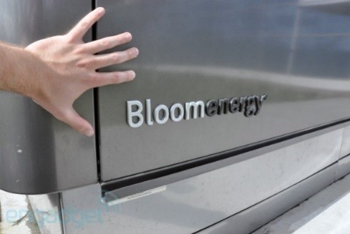

****Figure 21 : Bloom box, a stationary fuel cell manufactured by Bloomenergy

### Horizon Fuel Cell Technologies

Horizon is currently the largest micro fuel cell producer and the largest producer of PEM fuel cell stacks below 1,000 W. Today, the firm produces compact, lightweight PEM fuel cells at various performance levels, and also delivers hydrogen storage and on-site hydrogen generation solutions for multiple applications. The company was founded in 2003 and it currently owns five subsidiaries around the globe.[15]

**PEM:**

A semipermeable membrane generally made from ionomers and designed to conduct protons while being impermeable to gases such as oxygen or hydrogen.



[**http://en.wikipedia.org/wiki/Proton_exchange_membrane**](http://en.wikipedia.org/wiki/Proton_exchange_membrane)

Table 4 : Brief market information of Horizon Fuel Cell Technology

|  |  |
| --- | --- |
| Headquarters | Singapore |
| Fuel Cell Type | PEM |
| Market | Portable, Stationary(backup) |
| Application | Educational, consumer electronics, military, aerospace |

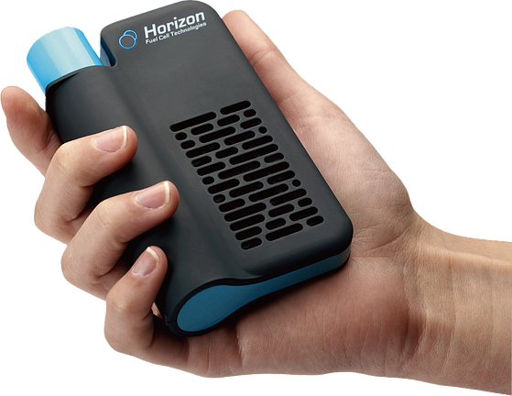

Figure 22 : Horizon MiniPak, FC product made from recycled plastics

### Intelligent Energy

Intelligent Energy also manufactures backup power in telecom sectors as an alternative to the commonly used diesel gases.

**Intelligent Energy Home Page:**



[**http://www.intelligent-energy.com/**](http://www.intelligent-energy.com/)

|  |  |
| --- | --- |
| Headquarters | Loughborough, United Kingdoms |
| Fuel Cell Type | PEM |
| Market | Portable, Stationary(backup) |
| Application | Aerospace, defense, generation portable power, automotive |

Intelligent Energy was founded in Loughborough, United Kingdom 2001. Its main focus is Proton Exchange Membrane type fuel cells. The firm partners with global companies that research on automotive, stationary power, and consumer electronics markets. Very notable accomplishments include collaborating with Suzuki Motor Corporation and built “Burgman” the first fuel cell scooter to achieve European Whole Vehicle Type Approval, and supplying fuel cells to Boeing who used it for the first fuel cell aircraft.[16]

Table 5: Brief market information of Intelligent Energy



NedStack obtains hydrogen partly from Chlorine industry by-product and uses the same hydrogen to generate power for chlorine plants resulting in a saving of upto 20% on energy consumption of the plants.

**Here’s the link to more info regarding Nedstack:**



[**http://www.nedstack.com/**](http://www.nedstack.com/)

Figure 23 : A fuel cell taxi developed by Intelligent Energy

### Nedstack

Nedstack is a PEM fuel cell stack provider for system integrators which deliver energy systems to the telecom, rail, and utilities industries. The company was founded in 1998 when seven engineers took over AkzoNobel’s PEM activities. Right now, over 1,000 Nedstack fuel cells are in operation world-wide mostly as backup power sources.[17]

Table 6: Brief market information of Nedstack

|  |  |
| --- | --- |
| Headquarters | Amhem, The Netherlands |
| Fuel Cell Type | PEM |
| Market | Transportation, Stationary(backup) |
| Application | Stationary power, telecommunication backup, buses |

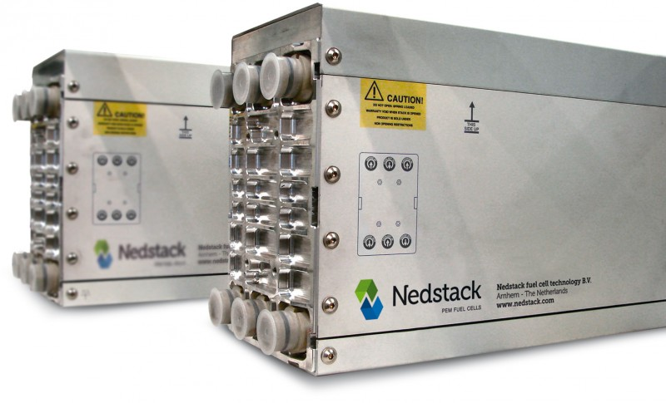

Figure 24 : PEM Fuel Cells by Nedstack

### panasonicPanasonic

**Panasonic’s Homepage:**



<http://panasonic.net>

**DMFC:**Direct Methanol Fuel Cell

DMFC uses ethanol instead of hydrogen fuels. The efficiency is quite low for these cells. Hence, they are mostly used in portable applications.

**Scan the QR code below for more information on DMFC**:



[**http://en.wikipedia.org/wiki/Direct_methanol_fuel_cell**](http://en.wikipedia.org/wiki/Direct_methanol_fuel_cell)

The firm was founded in the year 1918, at the moment it was known as Matsushita Electronics, the company now comprises more than 500 sub-groups. The company was the first to manufacture a DMFC laptop which was capable of operating continually on battery for 20 hours and displayed it publicly at the International Consumer Electronics Show, 2006 ’. The firm is also one of the largest global manufacturers for residential CHP, and in recent years, the company managed to miniature and simplify fuel cell’s structures.[18] [19]

Table 7: Brief market information of Panasonic

|  |  |
| --- | --- |
| Headquarters | Osaka, Japan |
| Fuel Cell Type | DMFC,PEM |
| Market | Stationary, Portable |
| Application | CHP units, Consumer Electronics,DMFC |

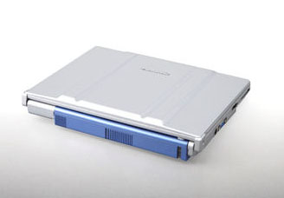

Figure 25 : A Panasonic laptop operating on fuel cell[20]

### plug-powerPlug Power

**Do you know?**

Walmart uses multiple units of GenDrive® fuel cell, a Plug Power’s product, to provide power for its distribution centres all around USA and Canada.

**More about Plug Power and its products:**



[**http://ww.plugpower.com/**](http://ww.plugpower.com/)

Plug Power is a major player in the PEM fuel cell material handling equipment market. The company was incorporated the year 1997 as a joint venture between Edison Development Corporation and Mechanical Technology Inc. Right now, the company mainly focuses on GenDrive®, a PEMFC designed for industrial vehicles especially material handling equipment and distribution facilities. The company has deployed over 3,000 GenDrive® units with run times exceeding 8.5 million hours.[21]

Table 8: Brief market information of Plug Power

|  |  |
| --- | --- |
| Headquarters | Latham, New York |
| Fuel Cell Type | PEM |
| Market | Stationary, Transportation |
| Application | Material Handling Equipment |

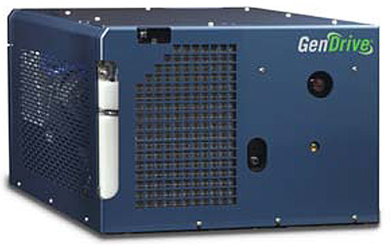

Figure 26 : GenDrive, a forklift fuel cell manufactured by Plugpower [22]

### SFC Energy

**SFC Energy:**



SFC currently partners up with Volkswagen Corp. to develop “Volkswagen T5” a light commercial vehicle powered by fuel cell.

**T5 article on science-direct:**



[**http://www.sciencedirect.com/science/article/pii/S1464285915301085**](http://www.sciencedirect.com/science/article/pii/S1464285915301085)

**More about SFC Energy:**



[**http://www.sfc.com/**](http://www.sfc.com/)

The firm produces power generator for mobile homes, yachts and vacation cabins. SFC Energy ally itself with other big companies in different industries and had already shipped more than 30,000 commercial products. The company’s facilities are located mainly in the Netherlands and Romania, its fuel cartridges are manufactured in Germany near Munich where its R&D department is located. SFC Energy also manufactures DMFC for mobile and off-grid power serving leisure, industrial and defense market.[23]

Table 9: Brief market information of SFC Energy

|  |  |
| --- | --- |
| Headquarters | Brunnthal, Germany |
| Fuel Cell Type | DMFC |
| Market | Stationary |
| Application | Leisure, industrial and defense |



Figure 27: Jenny, A portable fuel cell used in military operations[24]

### toshibaToshiba

**CEATEC:** Combined Exhibition of Advanced Technologies, an annual tradeshow in Japan.

**Learn more about Toshiba:**



[**http://www.toshiba.co.jp**](http://www.toshiba.co.jp)

In the year 1984, Toshiba operated an experimental 50 kW fuel cell power plant, the first power plant in Japan. The company actively researches on DMFC and PEM technologies for the Japanese market. Among the main products are residential PEM fuel cells and PAFC developed since 1990s. The company also demonstrates its DMFC- powered cell phones and MP3 players at the CEATEC conference which can operate for 320 hours using fuel cell and methanol fuel.[25]

Table 10: Brief market information of Toshiba

|  |  |
| --- | --- |
| Headquarters | Tokyo, Japan |
| Fuel Cell Type | DMFC, PEM |
| Market | Stationary, Portable |
| Application | Consumer Electronics, Residential |

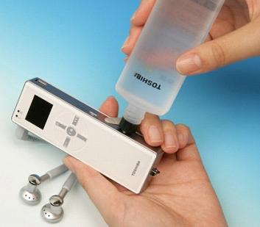

Figure 28: MP3 player powered by a methanol-based fuel cell[26]

# Policy Framework

It has been proven that innovations in their early stages need technology specific support, to prevent lock-in effects of earlier technologies from only incentivizing incremental innovations[27]. When developing such innovations new products or entering markets, firms are acting in a network of governmental influence, universities and customer. The actors, which are engaging in this network, can be classified as the role of the government and the interaction between firms and non-firm. This chapter will discuss the different influences of the institutional framework, which influence the development of technologies, by framing policies, opportunities and capabilities[28].

Support of new technologies may happen through R&D funding, support for demonstration trials, testing etc. Another form of influence can be planning incentives on a regional level, for example incentives for the use of fuel cells in new buildings[29].

For further discussions the countries with the highest support for fuel cells were chosen. Table 11 shows the average R&D budget in 2003 to 2005.

Table 11: R&D budgets average 2003-2005, rounded values in US$[30]

|  |  |  |  |  |  |  |  |
| --- | --- | --- | --- | --- | --- | --- | --- |
|  | PEM | MCFC | SOFC | H2 & FC | FC | Mobile FC | Stationary FC |
| Germany | x | x | x | 71 | 65 | 40 | 25 |
| Japan | x | x | x | 311 | 249 | 173 | 76 |
| USA | x | x | x | 249 | 151 | 105 | 46 |

The targets of stimulation in the fuel cell industry vary from region to region. In the US they are mainly driven by national security issues, in Europe by environmental targets and in Japan economic (high value manufacturing) as well as environmental targets and energy security. As shown in Part 2 there are several technologies, policies may vary from technology to technology depending on which focus is set and therefore create competition between those. Also other technologies compete or complement fuel cell. Incentives can have a high influence on creating the wanted effects[31] [32]. One of the main indicators of political influence are the expenditures for R&D in this area. In the following part, the situation in the three countries which are ranked highest with regard to expenditures are analyzed[33].

Although often seen together hydrogen and renewable energies have some distinctions, which influence the policies, as it is unlikely that the same policies for both technologies will work. Hydrogen is an energy carrier and therefore needs infrastructure for production and distribution. Hydrogen has to be made compatible for the existing infrastructure and cannot be blended. The future development is heavily relying on critical issues like storage where technological progress is necessary. Therefore a successful policy has to connect market requirements, climate requirements and the hydrogen technology development[34].

A study in Germany has shown that the political conditions influence the adoption of FC. There is a difference in the adoption through commercial and private users. For commercial user the investment decision is influenced by feed in laws for CHP systems and the oil and energy price. Private consumers are positively affected by a future oriented energy policy and clear law statements. Whereas commercial users deny subventions, because they are unreliable, private users endorse subventions to cover expenses which arouse by the use of FC[35].

## Situation in Japan

Due to the lack of fossil fuel sources Japan’s government is heavily investing in fuel cells and their research during the last years through R&D funding[36] [37] [38]. Already in 1974 the sunshine project was launched to examine hydrogen power among other renewable energy sources. Around 1980 the development was pushed by the moonlight project which aimed at developing fuel cells. With the new sunshine project of 1993 the effort on PEMFC was increased. All the efforts culminate in the millennium project from 2000. This is including R&D for PEMFC for use in automobile and residential application. This project is flanked by another program to develop tests and evaluation for safety and reliability standards which is stated to be a critical factor for the adoption of a new technology[39]. As a result of the announcement of Daimler-Benz of their failed plan to commercialize fuel cells, the government developed a strategic plan. According to this a partnership between METI and several Japanese fuel cell companies is established and called JHFC project. The intention of this project was mainly focused on the development of a FCV and surrounding infrastructure like hydrogen production, storage and filling. The development is characterized by a high degree of cooperation between government and industry, which is significant for high corporatist countries. The plan was divided in three phases. The first phase from 2002 to 2005 was intended to develop a hydrogen infrastructure and to determine performance statistics. The aim of the second phase from 2006 to 2010 was to develop standards investigate about policies and reduce costs. Besides this plan there was an agreement of the Japanese car manufacturers to release fuel cell vehicles by 2015[40]. In 2002 the Japanese government announced the target to reach 15 GW produced by stationary fuel cells in 2030. Besides funding, another influence of the government, is the research on the practical use of fuel cells. Japan has a clear focus on creating new markets for fuel cell CHP. The Japanese effort is among the highest[41].

**METI**: Ministry of Economy, Trade, and Industry (Japan)

**JHFC** : Japan Hydrogen and Fuel Cell

**FCV** : Fuel Cell Vehicle

**JTI** : Joint technology initiative

Using FCV and stationary appliances, Japan intends to use $ 4 billion for hydrogen usage and is expecting that by 2020 all road vehicles are powered by hydrogen fuel cells. The government is also funding manufacturers and an estimated value of 380 million $/year is done for research and commercialization of FC[42].

## Situation in the USA

The electricity market in the US is decentralized and also the framework for fuel cells is different in the states. California, Connecticut, New York, Ohio and South Carolina are the most supporting countries[43]. In contrast to Germany or Japan there is less support for creating a market for fuel cell CHP. The SECA program is focusing on SOFC for small stationary use. While SOFC may be the best choice for electricity generation it is lacking behind PEMFC. Besides the US Department of Defense is also investigating about residential fuel cells in military related fields.[44] The US department of energy has started a Hydrogen Program. Furthermore there is a direct subsidy support for manufacturing facilities.[45] Until 2014 an annually expense of $640 was made and in addition a $3,000/ kW purchase incentive tax credit was granted[46]**.**

## Situation in Germany

As a part of the EU the German policies have also to be seen in the context of the European framework, as the national framework is largely shaped by the European context. The general consent within the EU is that the “further development and market introduction” is desirable, as it can be a carbon neutral substitute for fossil fuels. One of those projects which empower fuel cell is the JTI in which frame 1 billion € will be spend from 2008 to 2017 [47] It was shown that Germany is one of the most innovative regions regarding fuel cells[48][49]. The public federal funding amounts 8-10 million every year. For the time 2001-2003 additionally 15 million were added in the “program on investment into the future”. The Helmholtz foundation, which undertakes basic research is supported with 15 million annually. Besides financial support, politicians promote hydrogen power, e.g. by presenting newest technologies[50]. The German government often proved to create new markets for new energy forms, e.g. with the “feed in law” from 1991 which guarantee a specific price for electricity generated by renewable energies. Germany is creating a market for fuel cell CHP within a broader range of technologies. To further develop fuel cells for the residential market there is an extensive ZIP program. Another indicator is how much new technologies are encouraged as this is creating an atmosphere in which firms will experiment more. Japan and the US may have the highest spending for R&D, but the highest use of renewable energies is reached in Germany. A main reason for this is the feed-in law.[51]. Another influence is the taxation, in Germany hydrogen is taxed when used as a motor fuel[52]. Furthermore there is the NOW program. Germany also makes use of subsidies for capital cost and give feed in tariffs for fuel cell CHP[53]. In difference to the USA or Japan Germany heavily pushes R&D in fuel cells but has now subsidies for e.g. buying a FCEV.[54] Till 2017 an investment sum of $1.1 billion is calculated.[55]

## Conclusion

Most of the policies are facing the same problem. On the one hand they have to be broad enough to create new markets and encourage firms to enter, but on the other hand they are focused on specific technologies where there is the greatest chance to success. A proposed solution includes to keep regulatory measures flexible while focusing R&D on special technologies[56].

# Future perspectives

## Fuel Cells as Off-Grid Power Source[57]

Prior to the London’s Olympic Games, the UK government decided that the security level in roads and motorways could still be increased by installing CCTVs on strategically important locations. However, the people involved in the project of providing energy sources for these CCTV realized that connecting these cameras to the grid would cost an absurdly high amount of budget from the government even without considering the maintenance cost of the grid itself. The construction engineers also argued that the construction would take up two years provided that sufficient manpower, materials and budgets are provided.

The government then turned to off-grid power as the ultimate solution to minimize the cost and time spent in installing the CCTVs system. Two fuel cell companies called ‘FCS’ and ‘UPS systems’ came into interest of the government. The companies installed stationary fuel cells at remote location in order to supply power for the fuel cells 24/7 the technology is superior to other renewable energy sources like wind energy and solar energy as the energy produced is stable regardless of the changing weather or climate conditions as long as fuel hydrogen is continually supplied. From the client’s perspective, the fuel cells are easier to deal with than batteries mainly because of the lighter weight, relatively more compact size and longer unit lifetime. This means that the maintenance team can actually perform maintenance more easily and economically. The fact that the country did not have to consider about the space and equipment for recharging the batteries for the entire highway itself made fuel cells easily became the solution for the UK government.

**Internet of things:** This term refers in this case to the project of enabling objects to interact with each other in order to minimize “useless” human interventions and to optimize their applications on a large scale.

From our point of view, fuel cells can also be used in similar scenarios where off-grid power systems are needed under the fact that weather and climate conditions are unstable. The technology is even more appealing to environmentalists as it produces zero noise and air pollution.

## Hydrogen Infrastructure[58]

Before hydrogen fuel cell vehicles can become a successful commercialization of international scale, an update in infrastructure and equipment must be established with the support of government institutions and society: hydrogen pipeline transport, as the name implies, is the transportation of hydrogen gas through a pipe. Sufficient length, quantity and area coverage of the piping system is mandatory in order to supply sufficient amount of hydrogen to all the vehicles in the country; hydrogen refueling stations, these stations will be used to refuel vehicles with hydrogen thus essentially it functions acts more or less the same as a petrol station, the main difference between the two is simply the fuel type. As for major countries, the USA for example, The National Renewable Energy Laboratory believes that U.S. counties have the potential to produce more renewable hydrogen for fuel cell vehicles than the gasoline they consumed in 2002. Thus, fuel cell maybe a sensible alternative or a potential replacement of conventional fuels.[59]

This infrastructure would be all the more beneficial for the implementation if it integrated smart devices automatizing control and communication between the different components. Indeed, because fuel cells are often installed in systems involving renewable energy sources, it is to be managed in an optimized way that maximizes efficiency. Such results can be reached only if components are able to communicate with energy management systems (EMS) that make strategic decisions for the electrical networks. Such systems can be decentralized. I this case, it is each device that has its own microcontroller and is responsible for interacting with others. It today remains very complex to design such systems because of the rules that the components are to respect, but also the reliability of the communications. Fortunately, similar issues are present in more general internet of things applications. A potential way to solve this is given in a lately used technology: Block Chains. Indeed, thanks to cryptography, communication and transactions taking place on block chains are more secure and reliable, but also ae controlled in a decentralized and preprogrammed way. Such technologies therefore would enable better integration of fuel cells in smart networks and to bring more comprehensive benefits to end-users.

NREL’s researchers are working on developing sustainable Hydrogen production on this YouTube page:

**NREL’s Hydrogen Program**

[**https://www.youtube.com/watch?v=ZQ8YR_4vC_k**](https://www.youtube.com/watch?v=ZQ8YR_4vC_k)

## Technology

In the technology domain, there is one innovation that regards electrodes and therefore is awaited because it gives the possibility to reduce the manufacturing price a lot. Core-Shell electrodes are indeed offering to keep the properties presented by platinum electrodes at the same time as reducing the amount of precious metal contained in the component. The idea is to concentrate the platinum at the surface of the electrode so that it remains in small quantity[60]. Such kind of techniques are particularly interesting because they can be applied for existing types of fuel cells which have already been found usage and therefore will not require any change in terms of standards. Other improvements could also be brought by minimizing the cost of the electrolyte or catalysts consisting of the fuel cell.

Those innovations will have an impact by making the product more accessible to customers. But fuel cells already present quite a few advantages compared to combustion engines. Indeed, because of the little movement pieces are submitted to, it is a system that requires little maintenance. Fuel cells however can fail for mechanical or thermal degradation, or from a loss of efficiency of the different components (catalyst, electrode, and electrolyte)[61]. As a consequence, research and commercialization will also help improve system reliability.

These innovations have to be carried out because of the remaining immaturity of the technology and infrastructure. And indeed in terms of infrastructure, the hydrogen production equipment is rare. A fuel cell is supposed to provide a zero-emission option. To remain consistent, the best hydrogen production modes then are the non-polluting ones. In addition to this, as hydrogen needs to be produced and then used, the process is not efficient in terms of energy expenses. This can be seen as a defect. However, because natural energy sources cannot be controlled and therefore are hard to exploit efficiently, making hydrogen out of them is a great opportunity to make good usage of their potential. Nowadays this is done through electrolysis. More efficient options are being developed, including a promising one: direct solar water splitting. It can be done thanks to cells similar to photovoltaic ones where the splitting is powered by the sunlight. Another promising and original possibility is use microorganisms that will produce hydrogen through their photosynthesis process[62].

# Conclusion

Lorem ipsum dolor sit amet, consectetuer adipiscing elit. Nam nibh. Nunc varius facilisis eros. Sed erat. In in velit quis arcu ornare laoreet. Curabitur adipiscing luctus massa. Integer ut purus ac augue commodo commodo. Nunc nec mi eu justo tempor consectetuer. Etiam vitae nisl. In dignissim lacus ut ante. Cras elit lectus, bibendum a, adipiscing vitae, commodo et, dui. Ut tincidunt tortor. Donec nonummy, enim in lacinia pulvinar, velit tellus scelerisque augue, ac posuere libero urna eget neque. Cras ipsum. Vestibulum pretium, lectus nec venenatis volutpat, purus lectus ultrices risus, a condimentum risus mi et quam. Pellentesque auctor fringilla neque. Duis eu massa ut lorem iaculis vestibulum. Maecenas facilisis elit sed justo. Quisque volutpat malesuada velit.   
  
Nunc at velit quis lectus nonummy eleifend. Curabitur eros. Aenean ligula dolor, gravida auctor, auctor et, suscipit in, erat. Sed malesuada, enim ut congue pharetra, massa elit convallis pede, ornare scelerisque libero neque ut neque. In at libero. Curabitur molestie. Sed vel neque. Proin et dolor ac ipsum elementum malesuada. Praesent id orci. Donec hendrerit. In hac habitasse platea dictumst. Aenean sit amet arcu a turpis posuere pretium.   
  
Nulla mauris odio, vehicula in, condimentum sit amet, tempus id, metus. Donec at nisi sit amet felis blandit posuere. Aliquam erat volutpat. Cras lobortis orci in quam porttitor cursus. Aenean dignissim. Curabitur facilisis sem at nisi laoreet placerat. Duis sed ipsum ac nibh mattis feugiat. Proin sed purus. Vivamus lectus ipsum, rhoncus sed, scelerisque sit amet, ultrices in, dolor. Aliquam vel magna non nunc ornare bibendum. Sed libero. Maecenas at est. Vivamus ornare, felis et luctus dapibus, lacus leo convallis diam, eget dapibus augue arcu eget arcu.

# Appendix

## Detailed Table of Contents

1. Introduction 3

1.1 Intentions 3

1.2 History of Fuel Cells 5

1.3 Fuel Cell as an alternative? 5

1.4 Quick industry overview 6

2. Product Description 7

2.1 Introduction 7

2.2 Technologies 8

2.2.1 PEMFC 8

2.2.2 DMFC 9

2.2.3 AFC 9

2.2.4 PAFC 10

2.2.5 SOFC 11

2.2.6 MCFC 11

2.2.7 Conclusion 12

2.3 Applications 13

2.3.1 Transport 13

2.3.2 Stationary 14

2.3.3 Portable 15

2.3.4 Conclusion 16

2.4 Infrastructure 16

2.4.1 Distribution Facilities 16

2.4.1.1 Delivery 17

2.4.1.2 Hydrogen Storage 18

2.4.2 Hydrogen Production 19

2.4.2.1 Gas Reforming 19

2.4.2.2 Electrolysis 20

3. Market Perspective 21

3.1 Introduction 21

3.2 Investment Cost Reduction 22

3.3 Intellectual Property 22

3.4 Quantity of Fuel Cells Shipped 24

3.5 Company Profiles 27

3.5.1 Bloomenergy 27

3.5.2 Horizon Fuel Cell Technologies 28

3.5.3 Intelligent Energy 29

3.5.4 Nedstack 30

3.5.5 Panasonic 31

3.5.6 Plug Power 32

3.5.7 SFC Energy 33

3.5.8 Toshiba 34

4. Law and Governmental Regulations 36

4.1 Situation in Japan 38

4.2 Situation in the USA 39

4.3 Situation in Germany 39

4.4 Conclusion 40

5. Future perspectives 41

5.1 Fuel Cells as Off-Grid Power Source 41

5.2 Hydrogen Infrastructure 42

5.3 Technology 43

6. Conclusion 44

7. Appendix 46

7.1 Detailed table of contents 46

7.2 List of figures 48

7.3 List of tables 49

7.4 References 50

7.4.1 Bibliography 50

7.4.2 Picture Credits 51

## List of Figures

Figure 1: Logic Model 4

Figure 2: Schematic representation of the structure of a PEMFC 8

Figure 3: Schematic representation of the structure of an AFC 9

Figure 4: Schematic representation of the structure of a PAFC 10

Figure 5: Schematic representation of the structure of a SOFC 11

Figure 6: Schematic representation of the structure of an MCFC 11

Figure 7: A hydrogen powered bus in London 13

Figure 8: SOFC installation by Bloom Energy at a NASA centre 14

Figure 9: A fuel cell charger designed by Brunton. It uses small hydrogen reservoirs to refuel. 14

Figure 10 The air present on the surface of Earth is made of 78,08 % of dinitrogen, 20,95 % of dioxygen, and 1 % of other gas. Hydrogen represents only a 0,000072 % fraction of it. 15

Figure 11: A hydrogen "plug" on a car 16

Figure 12: Hydrogen high pressure tubes designed by Shijiazhuang Enric Gas Equipment Co. 17

Figure 13 : Illustration of the different storage modes for Hydrogen 18

Figure 14 : FC Investment Cost Reduction 21

Figure 15 : Top 10 Fuel Cell Energy Patent Assignees 2002 - 2014 22

Figure 16 : Fuel Cell Patents Geographic Distribution 22

Figure 17 : Fuel Cell MWs Shipped by Applications (2008-2013) 23

Figure 18 : Fuel Cell System Shipped by Application (2008-2013) 24

Figure 19 : Fuel Cell Systems Shipped by Major Manufacturer Countries (2008-2013) 24

Figure 20 : Fuel Cell Systems Shipped by Major Manufacturer Countries (2008-2013) 25

Figure 21 : Bloom box, a stationary fuel cell manufactured by Bloomenergy 27

Figure 22 : Horizon MiniPak, FC product made from recycled plastics 28

Figure 23 : A fuel cell taxi developed by Intelligent Energy 29

Figure 24 : PEM Fuel Cells by Nedstack 29

Figure 25 : A Panasonic laptop operating on fuel cell 30

Figure 26 : GenDrive, a forklift fuel cell manufactured by Plugpower 31

Figure 27: Jenny, A portable fuel cell used in military operations 32

Figure 28: MP3 player powered by a methanol-based fuel cell 33

Figure 29: Contributions to GitHub Repository BambuGMS/Industry-Analysis-Report from 15.03.2015-14.06.2015 47

## List of Tables

Table 1: Summary of the different fuel cells and their operating conditions 13

Table 2: Summary of the different applications for fuel cells 16

Table 3 : Brief market information of Bloomenergy 27

Table 4 : Brief market information of Horizon Fuel Cell Technology 28

Table 5: Brief market information of Intelligent Energy 30

Table 6: Brief market information of Nedstack 30

Table 7:Brief market information of Panasonic 31

Table 8: Brief market information of Plugpower 32

Table 9: Brief market information of SFC Energy 33

Table 10: Brief market information of Toshiba 34

Table 11: R&D budgets average 2003-2005, rounded values in US$ 37

## Contribution on GitHub



Figure 29: Contributions to GitHub Repository BambuGMS/Industry-Analysis-Report from 15.03.2015-14.06.2015

## References

### Bibliography

Core-Shell Fuel Cell Electrodes - Energy Innovation Portal. En ligne : http://techportal.eere.energy.gov/technology.do/techID=1257, consulté le 30 mai 2015.

Hydrogen Production Processes | Department of Energy. En ligne : http://energy.gov/eere/fuelcells/hydrogen-production-processes, consulté le 30 mai 2015.

Fuel Cells: Discovering the Science (2013). En ligne : http://americanhistory.si.edu/fuelcells/origins/origins.htm, consulté le 6 mai 2015.

Fuel Cell History - Fuel Cell Today (2015). En ligne : http://www.fuelcelltoday.com/history, consulté le 6 mai 2015.

Andújar, J. M.; Segura, F. (2009) Fuel cells: History and updating. A walk along two centuries. In : Renewable and Sustainable Energy Reviews, vol. 13, n° 9, p. 2309–2322. DOI: 10.1016/j.rser.2009.03.015.

Bleischwitz, Raimund; Bader, Nikolas (2010) Policies for the transition towards a hydrogen economy: the EU case. In : The socio-economic transition towards a hydrogen economy - findings from European research, with regular papers, vol. 38, n° 10, p. 5388–5398. DOI: 10.1016/j.enpol.2009.03.041.

Brown, James E.; Hendry, Chris N.; Harborne, Paul (2007) An emerging market in fuel cells? Residential combined heat and power in four countries. In : Energy Policy, vol. 35, n° 4, p. 2173–2186. DOI: 10.1016/j.enpol.2006.07.002.

Canadian Hydrogen and Fuel Cell AssociationCanadian Hydrogen and Fuel Cell Association (2012) 10 Reasons to Support Hydrogen and Fuel Cell Funding. En ligne : http://www.chfca.ca/media/10_Reasons_Support_Funding.pdf, consulté le 6 mai 2015.

Dodds, Paul E.; Staffell, Iain; Hawkes, Adam D.; Li, Francis; Grünewald, Philipp; McDowall, Will; Ekins, Paul (2015) Hydrogen and fuel cell technologies for heating: A review. In : International Journal of Hydrogen Energy, vol. 40, n° 5, p. 2065–2083. DOI: 10.1016/j.ijhydene.2014.11.059.

EEREEERE (2015) HYDROGEN PRODUCTION: NATURAL GAS REFORMING. EERE. Washington, DC 20585. En ligne : http://energy.gov/eere/fuelcells/hydrogen-production-natural-gas-reforming.

FuelCellTodayFuelCellToday Applications. FuelCellToday. En ligne : http://www.fuelcelltoday.com/applications, consulté le 14 avril 2015.

FuelCellTodayFuelCellToday Technologies. FuelCellToday. En ligne : http://www.fuelcelltoday.com/technologies, consulté le 14 avril 2015.

Hart, David; Lehner, Franz; Rose, Robert; Lewis, Jonathan (2014) The Fuel Cell Industry Review 2014. E4tech, éd. E4tech (The Fuel Cell Industry Review, 1). En ligne : http://www.fuelcells.org/pdfs/TheFuelCellIndustryReview2014.pdf, consulté le 1 avril 2015.

Haslam, Gareth E.; Jupesta, Joni; Parayil, Govindan (2012) Assessing fuel cell vehicle innovation and the role of policy in Japan, Korea, and China. In : HYFUSEN Special Issue for the 4th National - 3rd Latin American Conference on Hydrogen and Sustainable Energy Sources (HYFUSEN), 6-9 June 2011, Mar Del Plata, Argentina, vol. 37, n° 19, p. 14612–14623. DOI: 10.1016/j.ijhydene.2012.06.112.

International Energy Agency Staff (2008) Energy Policies of Iea Countries Japan. 2008. Washington, Biggleswade : Organization for Economic Cooperation & Development; Turpin Distribution Services Limited [Distributor].

Karger, Cornelia R.; Bongartz, Richard (2008) External determinants for the adoption of stationary fuel cells—Infrastructure and policy issues. In : Energy Policy, vol. 36, n° 2, p. 798–810. DOI: 10.1016/j.enpol.2007.10.024.

Katharina Hamberger (2015) Die Chancen der Brennstoffzellen-Technologie. In : Deutschlandfunk, 7 février 2015. En ligne : http://www.deutschlandfunk.de/antrieb-der-zukunft-die-chancen-der-brennstoffzellen.724.de.html?dram:article_id=310237.

nedstacknedstack Fuel Cell Types. nedstack. En ligne : http://www.nedstack.com/technology/fuel-cell-types, consulté le 14 avril 2015.

P. Lako; M.E. Ros (2006) R&D expenditure for H2 and FC as indicator for political will.

Pudukudy, Manoj; Yaakob, Zahira; Mohammad, Masita; Narayanan, Binitha; Sopian, Kamaruzzaman (2014) Renewable hydrogen economy in Asia – Opportunities and challenges: An overview. In : Renewable and Sustainable Energy Reviews, vol. 30, n° 0, p. 743–757. DOI: 10.1016/j.rser.2013.11.015.

Tanner, Anne Nygaard (2014) Regional Branching Reconsidered: Emergence of the Fuel Cell Industry in European Regions. In : Economic Geography, vol. 90, n° 4, p. 403–427. DOI: 10.1111/ecge.12055.

U.S. Department of Energy (December 2014) State of the States: Fuel Cells in America 2014.

Vasudeva, Gurneeta (2009) How national institutions influence technology policies and firms’ knowledge-building strategies: A study of fuel cell innovation across industrialized countries. In : Research Policy, vol. 38, n° 8, p. 1248–1259. DOI: 10.1016/j.respol.2009.05.006.

Wu, Jinfeng; Yuan, Xiao Zi; Martin, Jonathan J.; Wang, Haijiang; Zhang, Jiujun; Shen, Jun et al. (2008) A review of PEM fuel cell durability. Degradation mechanisms and mitigation strategies. In : Journal of Power Sources, vol. 184, n° 1, p. 104–119. DOI: 10.1016/j.jpowsour.2008.06.006.

### Picture Credits

|  |  |  |
| --- | --- | --- |
| Page |  | Retrieved from |
| Front Page |  | http://isis-innovation.com/opportunities/hydroxsil/ |
| 3 |  | https://nckuenergy.wordpress.com/ |
| 7 |  | http://c4dnetwork.com/board/attachment.php?s=b244728d96df8cad72364c8accd57115&attachmentid=41629&d=1395932039 |
| 14 – 1 |  | http://commons.wikimedia.org/wiki/File:First_London_fuel_cell_bus_WSH62995_%28LK60_HPN%29_VDL_SB200_Wrightbus_Pulsar,_Catherine_Street,_route_RV1,_20_May_2011.jpg |
| 14 – 2 |  | http://c0688662.cdn.cloudfiles.rackspacecloud.com/download_image_Bloom_018.jpg |
| 15 |  | http://www.digitaltrends.com/cool-tech/brunton-hydrogen-reactor-portable-power-pack/ |
| 17 – 1 |  | http://www.fleetbydieteren.be/lhydrogene-carburant-demain/ |
| 17 – 2 |  | https://thenounproject.com/accounts/login/?next=/term/pipeline/53646/ |
| 17 – 3 |  | http://www.snap2objects.com/2009/02/free-means-of-transportation-vector-silhouettes/ |
| 18 |  | http://www.cimc.com/en/enterprise/gasequipment/index.shtml?subComId=1542 |
| 19 |  | http://energy.gov/eere/fuelcells/hydrogen-storage-basics-0 |
| 21 |  | http://www.cea.fr/var/site/storage/images/jeunes/mediatheque/nouvelle_phototheque/energies_renouvelables/les_piles_a_combustibles/monocellule_de_pile_a_combustible/1323897-1-fre-FR/monocellule_de_pile_a_combustible.jpg |
| 28 |  | http://www.therecycletimes.com/wp-content/uploads/2011/07/bloom-energy-hands-literally-rm-eng-500x332.jpg |
| 29 |  | http://static.wixstatic.com/media/047f54_27db44260b9e1d7c33d0a8aaab2586c8.png_srz_559_432_75_22_0.50_1.20_0.00_png_srz |
| 30 |  | http://www.themanufacturer.com/wp-content/uploads/2012/09/Fuel-cell-taxi-Intelligent-Energy1.jpg |
| 31 |  | http://www.hymove.nl/wp-content/uploads/2014/10/nieuws_18224_20679_item_original.jpg |
| 32 |  | http://cdn.phys.org/newman/gfx/news/hires/2008/2-panasonicfue.jpg |
| 33 |  | http://www.fleetsandfuels.com/wp-content/uploads/PlugPowerSeries1000.jpg |
| 34 |  | http://www.sfc-defense.com/sites/default/files/imagecache/gallery_large/sites/default/files/gallery/jenny_600s_1.jpg |
| 35 |  | http://i.cmpnet.com/audiodesignline/2005/09/ToshibaFCFig1.JPG |
| 36 |  | http://www.businessgreen.com/IMG/164/260164/bloom-energy-boxes.jpg |
| 41 |  | http://www.car-engineer.com/wp-content/uploads/2013/11/PEMFC-CEA-illustration.jpg?d5a4a8 |
| 44 |  | http://www.workshop-europeanccsday.ademe.fr/Data/kmclientv7/wysiwyg/F_752249ff0a6e1ea3f999d5ad2041a98e53429e7d60bec.jpg |

1. Fuel Cells: Discovering the Science 2013
2. Fuel Cell History - Fuel Cell Today 2015
3. Fuel Cell History - Fuel Cell Today 2015
4. Andújar et Segura 2009
5. Brown, Hendry et Harborne 2007
6. nedstack
7. FuelCellToday
8. FuelCellToday
9. Hart et al. 2014
10. EERE 2015
11. http://www.cepgi.com/2015/04/2014-year-end.html
12. http://www.recovery.gov/arra/Pages/default.aspx
13. http://www.hyundai.co.uk/about-us/environment/hydrogen-fuel-cell
14. http://www.bloomenergy.com
15. http://www.horizonfuelcell.com
16. http://www.intelligent-energy.com/
17. http://www.nedstack.com/
18. http://panasonic.net
19. http://www.theregister.co.uk/2008/10/20/panasonic_dmfc_demo/
20. http://kythuatso.net/the-gioi-so/Panasonic-trien-lam-laptop-pin-nhien-lieu-9ff.html
21. http://ww.plugpower.com/
22. http://www.fleetsandfuels.com/wp-content/uploads/PlugPowerSeries1000.jpg
23. http://www.sfc.com/
24. http://[www.sfc-defense.com](http://www.sfc-defense.com/page/portable-power)/
25. http://www.toshiba.co.jp
26. http://www.informationweek.com/toshibas-mp3-player-rocks-on-with-alcohol/d/d-id/1036125?
27. Bleischwitz et Bader 2010
28. Vasudeva 2009
29. Dodds et al. 2015
30. P. Lako et M.E. Ros
31. Vasudeva 2009
32. P. Lako et M.E. Ros 2006
33. P. Lako et M.E. Ros 2006
34. Bleischwitz et Bader 2010
35. Karger et Bongartz 2008
36. International Energy Agency Staff 2008
37. Brown, Hendry et Harborne 2007
38. Pudukudy et al. 2014
39. Brown, Hendry et Harborne 2007
40. Haslam, Jupesta et Parayil 2012
41. Brown, Hendry et Harborne 2007
42. P. Lako et M.E. Ros 2006
43. U.S. Department of Energy December 2014
44. Brown, Hendry et Harborne 2007
45. Dodds et al. 2015
46. Canadian Hydrogen and Fuel Cell Association 2012
47. Bleischwitz et Bader 2010
48. Tanner 2014
49. P. Lako et M.E. Ros 2006
50. P. Lako et M.E. Ros 2006
51. Brown, Hendry et Harborne 2007
52. Bleischwitz et Bader 2010
53. Dodds et al. 2015
54. Katharina Hamberger 2015
55. Canadian Hydrogen and Fuel Cell Association 2012
56. Brown, Hendry et Harborne 2007
57. http://www.fuelcellsystems.co.uk/fcapplications/case-studies/remote-off-grid-power-for-road-network-cctv/
58. http://www.researchgate.net/publication/233987484_Fuel_cell_electric_vehicles_and_hydrogen_infrastructure_status_2012
59. http://www.nrel.gov/docs/fy07osti/41134.pdf
60. Core-Shell Fuel Cell Electrodes - Energy Innovation Portal
61. Wu et al. 2008
62. Hydrogen Production Processes | Department of Energy